Community Action Partnership of Central Illinois
Corporate Office: 1800 5th Street, Lincoln, IL 62656
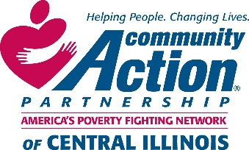
We are currently accepting bids for a 2020 School Bus for our Head Start program. For more detail please contact Chief Operations Officer Ryne Komnick by phone at 217-732-2159 ext. 244 or by email rkomnick@capcil.org.
Bids are to be submitted by Wednesday October 16, 2019.

